





SWAN VIEW, YARDLEY
PRICE LIST – DECEMBER 2024
21 apartments

Floor | Plot | Service Charge | Sq. Ft | Type | Price | Current Status
GF | APT 4 | £1,067.78 | 667 | 2 BEDROOM 1 BATH | £210,000 | AVAILABLE
GF | APT 5 | £1,119.45 | 699 | 2 BEDROOM 1 BATH | £210,000 | AVAILABLE
FF | APT 6 | £861.11 | 538 | 1 BEDROOM 1 BATH | £189,000 | AVAILABLE
FF | APT 7 | £861.11 | 538 | 1 BEDROOM 1 BATH | £189,000 | AVAILABLE
FF | APT 8 | £861.11 | 538 | 1 BEDROOM 1 BATH | £189,000 | AVAILABLE
FF | APT 9 | £637.22 | 398 | 1 BEDROOM 1 BATH | £152,250 | AVAILABLE
FF | APT 10 | £861.11 | 538 | 1 BEDROOM 1 BATH | £189,000 | AVAILABLE
FF | APT 11 | £861.11 | 538 | 1 BEDROOM 1 BATH | £189,000 | AVAILABLE
FF | APT 12 | £1,067.78 | 667 | 2 BEDROOM 1 BATH | £220,500 | AVAILABLE
FF | APT 13 | £878.33 | 548 | 1 BEDROOM 1 BATH | £191,100 | AVAILABLE
FF | APT 14 | £895.56 | 559 | 1 BEDROOM 1 BATH | £191,100 | AVAILABLE
SF | APT 15 | £912,78 | 570 | 1 BEDROOM 1 BATH | £192,150 | AVAILABLE
SF | APT 17 | £861.11 | 538 | 1 BEDROOM 1 BATH | £194,250 | AVAILABLE
SF | APT 18 | £861.11 | 538 | 1 BEDROOM 1 BATH | £194,250 | AVAILABLE
SF | APT 19 | £637.22 | 398 | 1 BEDROOM 1 BATH | £157,500 | AVAILABLE
SF | APT 20 | £861.11 | 538 | 1 BEDROOM 1 BATH | £194,250 | AVAILABLE
SF | APT 21 | £861.11 | 538 | 1 BEDROOM 1 BATH | £194,250 | AVAILABLE
SF | APT 22 | £1,067.78 | 667 | 2 BEDROOM 1 BATH | £231,000 | AVAILABLE
SF | APT 23 | £878.33 | 548 | 1 BEDROOM 1 BATH | £196,350 | AVAILABLE
SF | APT 24 | £878.33 | 559 | 1 BEDROOM 1 BATH | £196,350 | AVAILABLE
SF | APT 25 | £912.78 | 570 | 1 BEDROOM 1 BATH | £196,350 | AVAILABLE

LEASE 250 YRS
ONE PARKING SPACE PER APARTMENT

New Homes Sales Team - 0121 744 4144 opt 3
Email: newhomes@smart-homes.co.uk

APARTMENT OF THE MONTH – APARTMENT 5 - £210,000
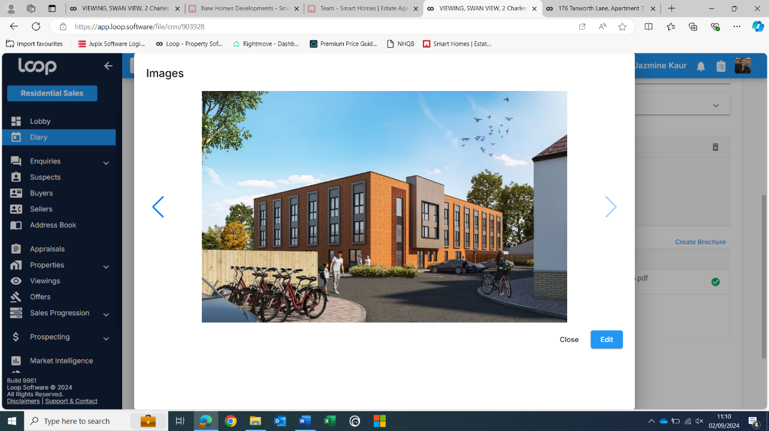
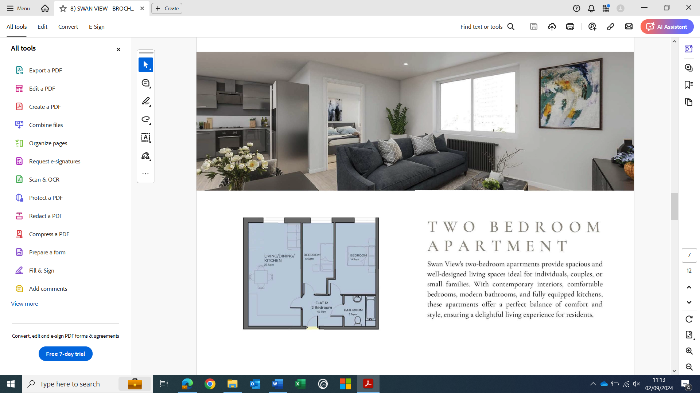
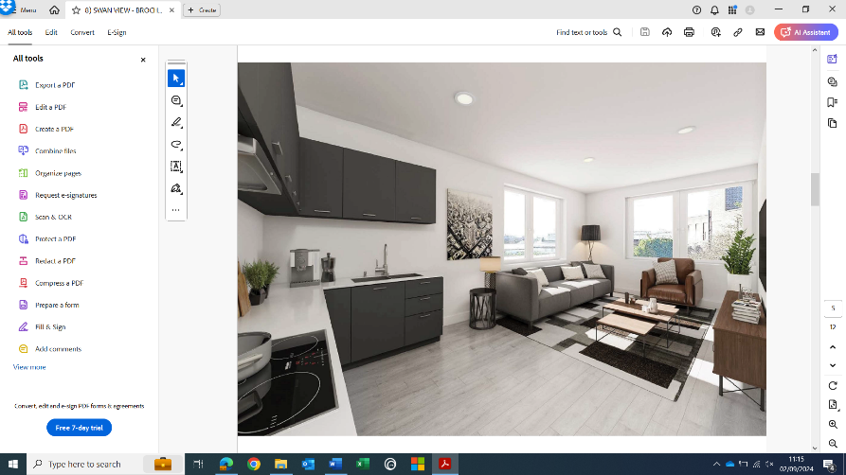
AVAILABLE NOW

